Logistic Note for Participants
7th 3C Forum: Inclusive Higher Education for Refugees

co-organised by Opening Universities for Refugees (OUR), the Centre for Asia Pacific Refugee Studies (CAPRS) at the University of Auckland, and Mahidol University
in collaboration with UNHCR

On Friday 1 December 2023 (0900 - 1700) at Prachasangkom Udompathana (Room 101)
Institute for Population and Social Research, Mahidol University, Salaya Campus, Bangkok

About the hosts:
Mahidol University is one of the most prestigious universities in Thailand, internationally known and recognized for the high calibre of research and teaching by its faculty, and its outstanding achievements in teaching, research, international academic collaboration and professional services. This diversified institution now offers top quality programs in numerous social and cultural disciplines, including the most doctoral programs of any institution in Thailand.
Opening Universities for Refugees (OUR) is an initiative that brings together institutions that offer, and are willing to offer, higher education courses and/or diploma and certificate programs to refugees and displaced people, and to create an open and accessible knowledge network accessible by all since 2016.
The Centre for Asia Pacific Refugee Studies (CAPRS) is a research institute based at the University of Auckland in New Zealand. CAPRS aims to respond to contemporary challenges of conflict and climate-induced displacement. CAPRS is driven by a transformative agenda that places social justice and human rights as core aspects of its work while working in close collaboration with refugee advocates, researchers, and community leaders to build local capacities in the Asia Pacific.
UNHCR, the UN Refugee Agency, is a global organisation dedicated to saving lives, protecting rights and building a better future for people forced to flee their homes because of conflict and persecution. Their vision is a world where every person forced to flee can build a better future.
This event is also sponsored by the International Development Research Centre, Canada through the project K4DM (The Knowledge for Democracy Myanmar initiative) aims to promote a new generation of young actors to enhance inclusion, gender equality, respect for diversity, and prosperity for all in Myanmar following the overthrow of Myanmar’s democratically elected government by the military in February 2021.

About Mahidol University, Salaya Campus
The Salaya Campus, situated along Phutthamonthon 4 Road, is located approximately 45 minutes from the center of Bangkok and around an hour's drive from Suvarnabhumi Airport. Mahidol University is committed to the development of Salaya Campus as an environmentally conscious and sustainable environment. With a focus on energy conservation, environmental sustainability, and fostering social cohesion and well-being, the university emphasizes the creation and maintenance of lush green open spaces, covering a minimum of 70% of the campus premises. Its objectives are to promote cycling, establishing outdoor learning and recreational spaces, and contribute to a harmonious and ecologically friendly campus setting.
Venue: the 7th 3C Forum: Inclusive Higher Education for Refugees will be held at Prachasangkom Udompathana (Room 101), Institute for Population and Social Research, Mahidol University.
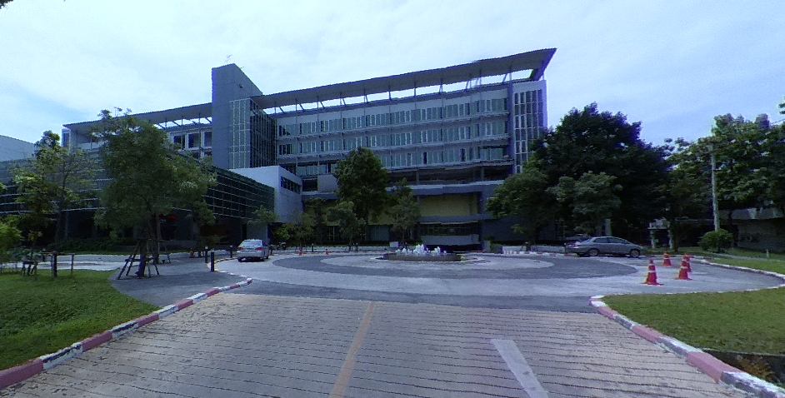
Address:
Institute for Population and Social Research, Mahidol University, Salaya Campus
999 Phutthamonthon 4 Road, Phutthamonthon, Nakhon Pathom 73170, Thailand
Website: https://ipsr.mahidol.ac.th/en/about-us/

Co-organiser/Host
Institute of Human Rights and Peace Studies (IHRP), Mahidol University
999 Phutthamonthon 4 Road, Phutthamonthon, Nakhon Pathom 73170, Thailand
Website: https://ihrp.mahidol.ac.th/th/home/

Venue Map
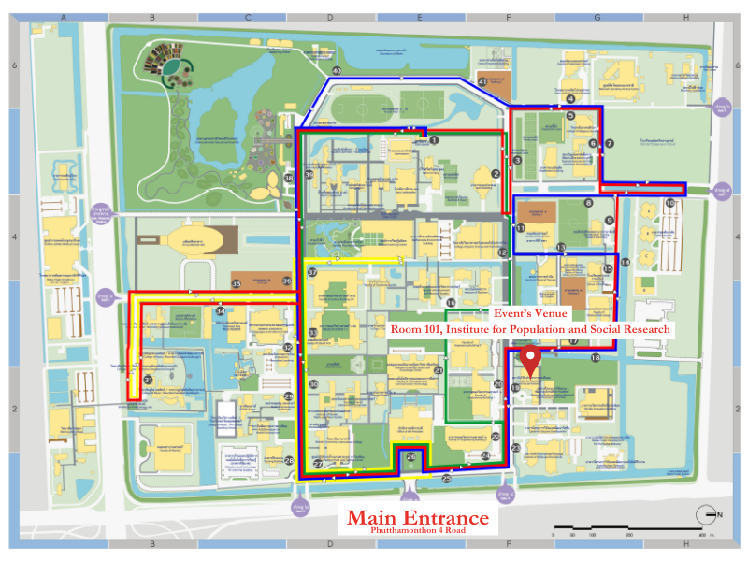
Meals
Lunch and refreshment will be provided in keeping with the schedule of the event.
Wifi
Due to internet security access kindly request Wifi usage upon registration.

